LoginScenario_TestForMarineValidLogin_Instance1_03-Jul-2017_05-37-58_AM_Enter_user_credentials.png

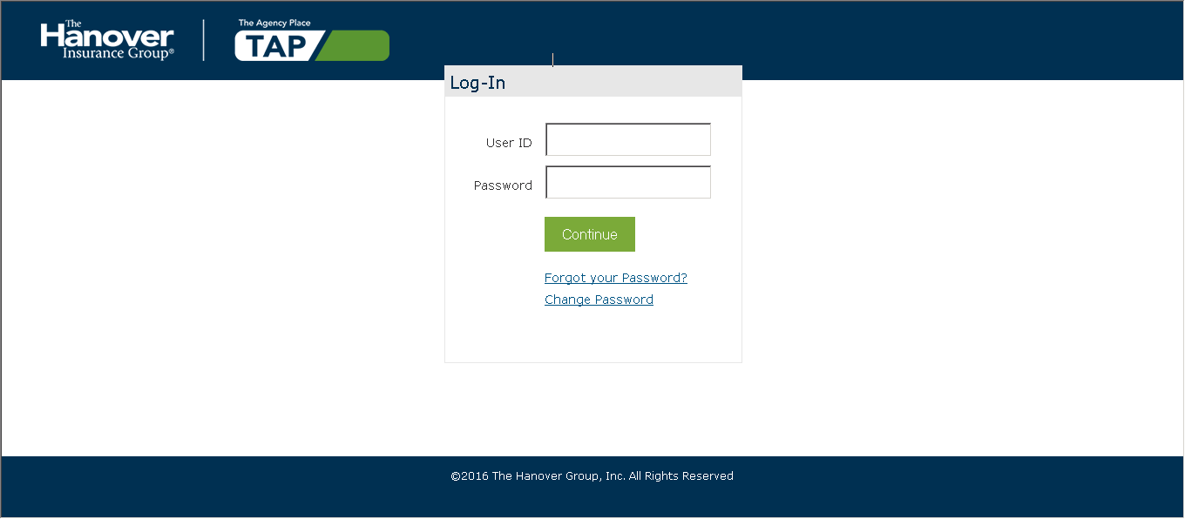

LoginScenario_TestForMarineValidLogin_Instance1_03-Jul-2017_05-37-59_AM_Login.png

